**MOTOR DESIGN**

**WEEK 1 ASSIGNMENT**

With the provided specs, L is expected to be 25 mH and Bgap is expected to be 1.5 T.

The geometry is simulated on Maxwell with ideal core (µr  is kept arbitrarily large and no saturation limit is set). Distribution of B magnitude across the core and a graph of Bmag versus distance across the air gap are depicted below.

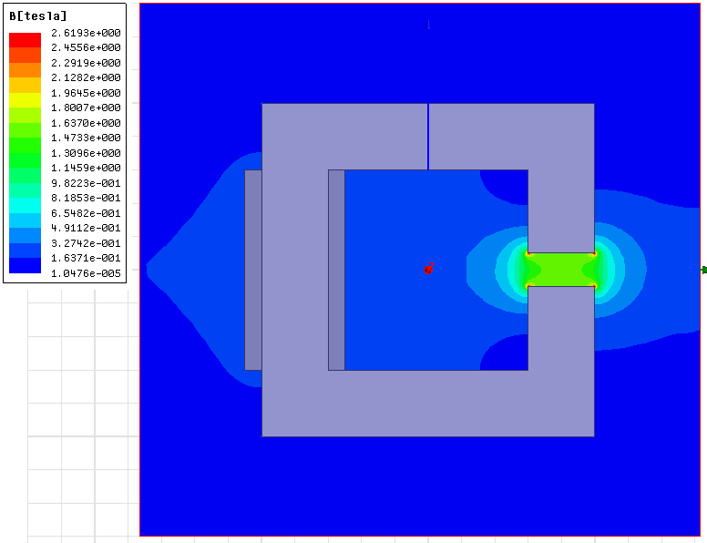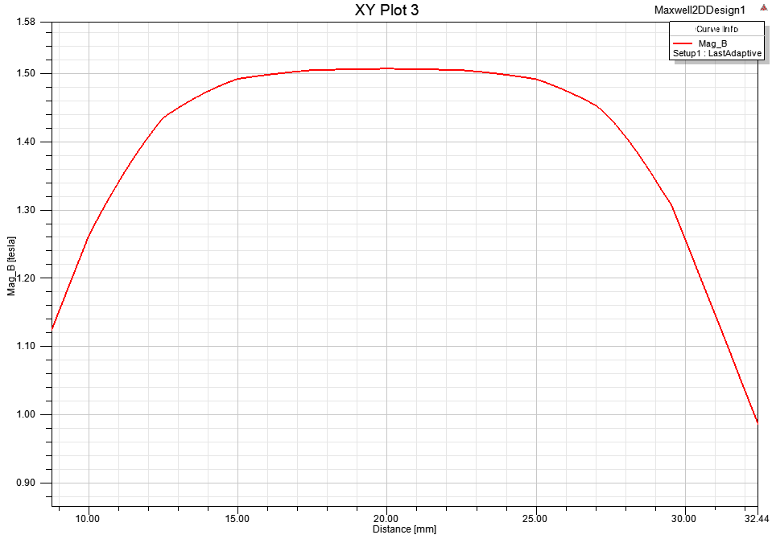

Simulation results agree with the theoretical approach since the core is assumed to be ideal. Now the core is modeled as a material with µr = 1000 but without saturation. Distribution of B magnitude across the core and a graph of Bmag versus distance across the air gap are depicted below.

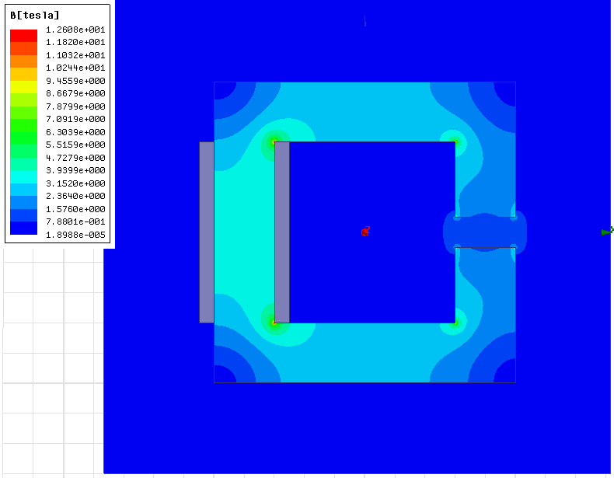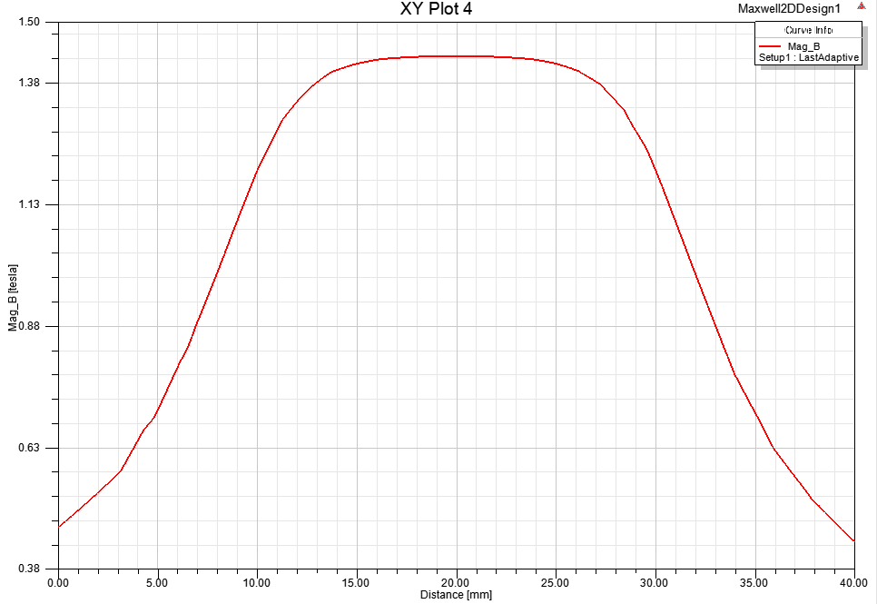

Some slight reduction of B is observed which agrees with the theory. Now, the core is modelled with saturation. Related graphs are repeated for this case below:

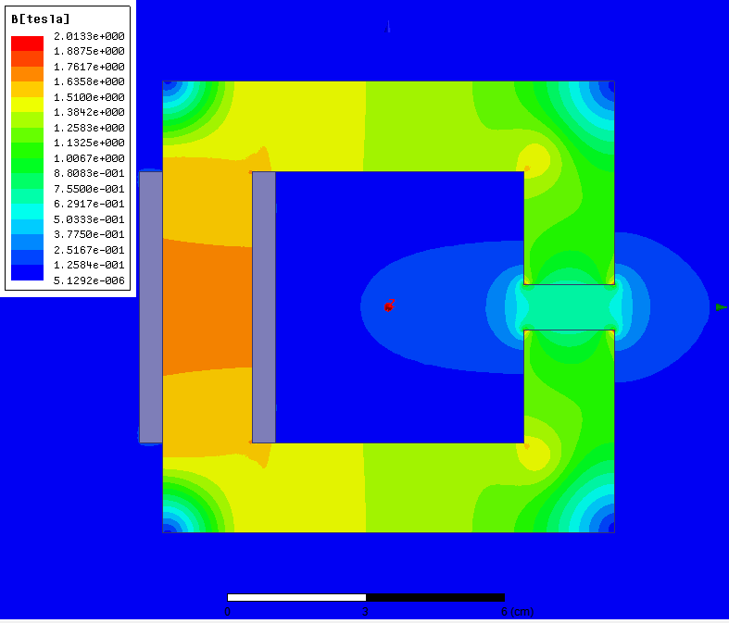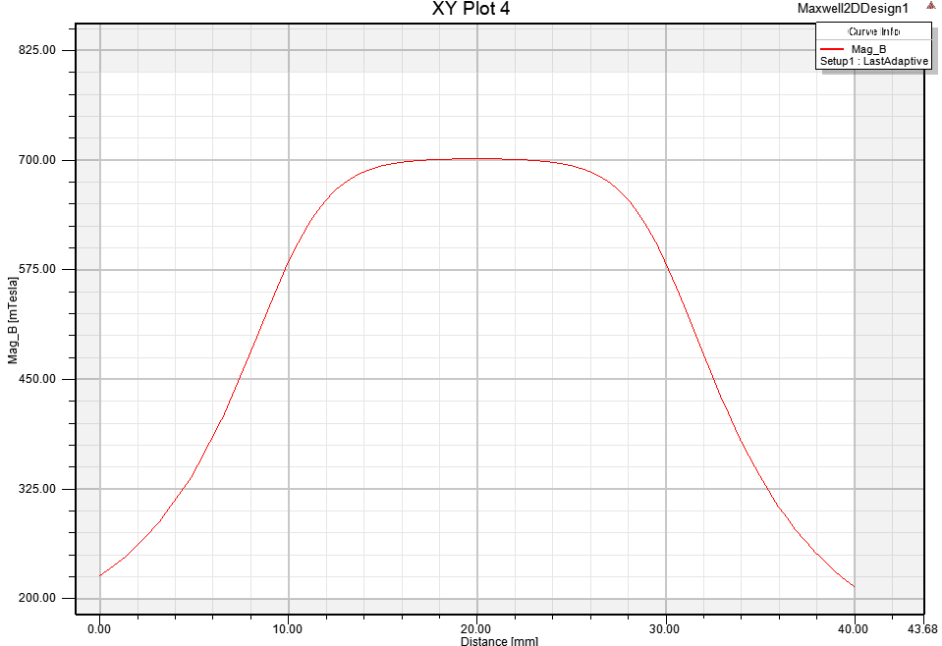

Effect of saturation on the core can be easily viewed on the above graph. Air gap B is also been reduced to 0.7 T due to the saturation effect. Finally, flux vectors are drawn to visualize the fringing effect below:

